**Miguel Martins Student ID: m228540**

**Progressive report. Control group**

**First aim:**

Create a 3D and editable model for the lathe’s bed.

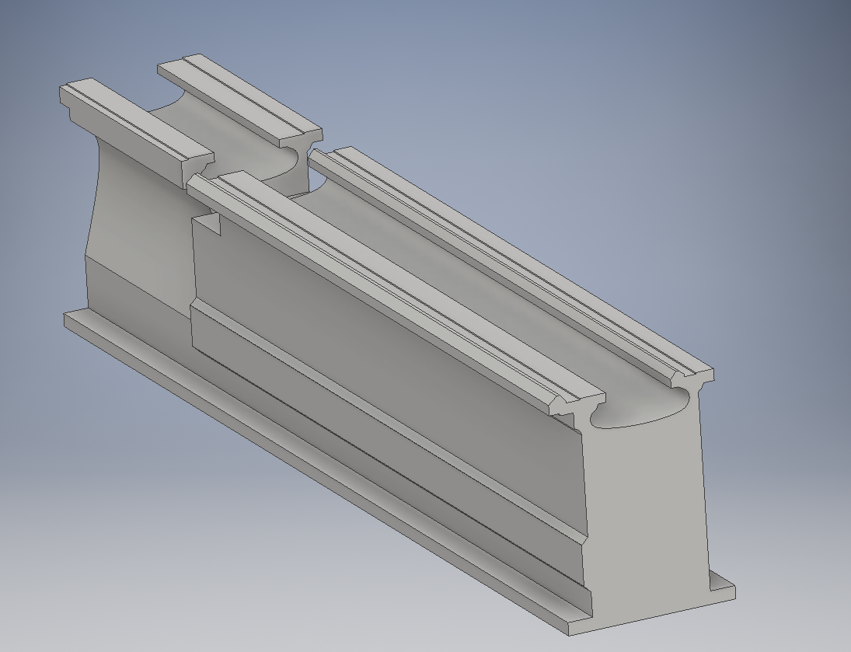

**Second aim:**

Calculate torques and forces exerted by the lathe to be able to select both motors and ball screws.

Initial stablished parameters:

|  |  |  |
| --- | --- | --- |
| Predominantly material for workpiece | High Carbon Steel | N/A |
| Depth of cut (max) | 6 | mm |
| Feed rate (max) | 0.5 | mm/rev |
| Chuck angular velocity (max) | 22 - 1800 | RPM |
| Coefficient of friction metal-metal | 0.16 [1] | N/A |
| Z-axis weight | 50 | Kg |
| X-axis weight | 25 | Kg |
| Manual angular velocity | 120 | RPM |
| Lead angle accuracy | 0.05 | mm |
| Ball screw length to be used for the Z-axis | 1100 | mm |

CNC lathe is required to be driven by ball screws and servo motors for their lowest factors of frictions and accuracy respectively. Therefore all following calculations are aimed at selecting a ball screw and a servo motor which can overcome torque, velocity and forces developed by the lathe.

For cutting force calculation:

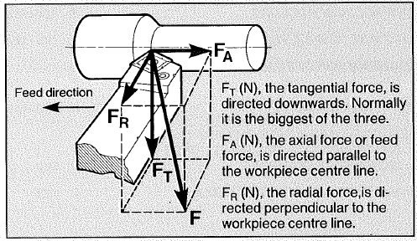

The approximate relationship of these components to each other is: $F_{T}:F_{A}:F_{R}=4:2:1$

Tangential cutting force ($F_{t}$) may be determined by:

$$F_{T}(N)=k_{s}×a×s$$

Where $k_{s}$ = specific cutting force (N/mm2)

a = depth of cut (mm)

s = feed (mm/rev)

As $k_{s}$ = 2300 N/mm2 for a workpiece of high carbon steel, it need to be corrected by three (3) factors which are insert geometry, entering angle of the tool and the feed rate chosen.

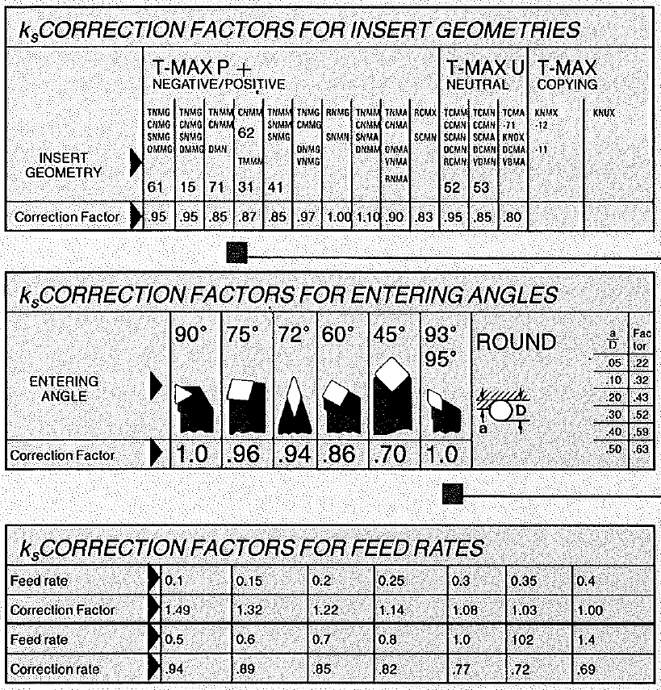

Assuming all these factors are equal to one, $k_{s}$ is:

$$k_{s}=2300×1×1×1=2300 N/{mm}^{2}$$

Thus,

$$F_{T}=2300 N/{mm}^{2}×6 mm×0.5 mm/rev=6900 N$$

And:

$$F_{A}=\frac{F_{T}}{2}=\frac{6900 N}{2}=3450 N$$

$$F_{R}=\frac{F_{T}}{4}=\frac{6900 N}{4}=1725 N$$

Since the lead angle accuracy is 0.05 mm and the effective thread length is greater than 1000 mm, the accuracy grade for the ball screw will be **C5 Precision Ball Screw [4].** Furthermore, most ball screw can provide an efficiency of 95%.

Additionally, the ball screw lead may be obtained as follow:

$$Lead=\frac{Chuck angular velocity \left(RPM\right)×Feed rate \left(\frac{mm}{rev}\right)}{Manual angular velocity \left(RPM\right)}=\frac{1800×0.5}{120}$$

$$=7.5 mm/rev$$

Rounding up the theoretical lead to match a standard lead screw ball from manufactures, lead is equal to **10 mm/rev. [5]**

Once cutting forces and ball screw’s lead have been calculated, forces due to friction and lathe’s components weight must be included for both X and Z axes. Thus,

|  |  |
| --- | --- |
| Z-axis (Apron) | X-axis (Tool post) |
|  |  |
| $$W=50Kg×9.81 m/s^{2}=490.5 N$$ | $$W=25Kg×9.81 m/s^{2}=245.5 N$$ |
| $$F_{F}=\left(6900N+490.5N\right)×0.16=1182.5N$$ | $$F_{F}=\left(6900N+245.5 N\right)×0.16=1143.2N$$ |
| $$F_{mot}=F_{F}+F_{A}=1182.5N+3450 N=4632.5N$$ | $$F_{mot}=F_{F}+F_{R}=1143.2N+1725 N=2868.2N$$ |
| $$T_{ball screw}=\frac{F_{mot}×Lead}{2π×η_{ball screw}×1000}$$ $$=\frac{4632.5N×10 mm/rev}{2π×0.9×1000}=8.2 Nm$$ | $$T_{ball screw}=\frac{F_{mot}×Lead}{2π×η_{ball screw}×1000}$$ $$=\frac{2868.2N×10 mm/rev}{2π×0.9×1000}=5.1 Nm$$ |
| $$T_{mot}=\frac{T_{ball screw}}{η_{motor safety factor}}=\frac{8.2 Nm}{0.75}$$ $$=10.9 Nm$$ | $$T_{mot}=\frac{T_{ball screw}}{η_{motor safety factor}}=\frac{5.1 Nm}{0.75}$$ $$=6.8 Nm$$ |

Finally,

References

[1] Website for factor friction <http://www.engineeringtoolbox.com/friction-coefficients-d_778.html>

[2] Ross’ Book

[3] Selecting ball screw guide

[4] Lead angle accuracy

[5] Ball screw details